**Problem Statement:**

* Today in rural area there is no proper communication between the government and farmers. The Middle Sellers are getting more profits compared to farmers and also does not provide any information about exact market rates and other government facilities. So the farmers do not get the facilities which they need and that’s the reason why the agriculture field is not developed properly.

**Objectives of the Project:**

* To maintain the reasonable rate for the benefit for the farmer.
* This application also takes feedbacks, complaints, problems from people directly.
* It also provides the good suggestion for specific problems from the specialist of those fields.

**Scope of the Project:**

* It is more helpful especially for farmers because it provides the information regarding to agriculture and weather forecasting. It is also helpful for local people that provide the information about government accurate crops rates. It also provides the facilities that the people can directly communicate to APMC and give suggestions and complaints to higher authorities.
* It is specially made for the farmers because it provides all the information regarding to agriculture. It’ll provide live hourly weather information. It’ll give market price of vegetables, seeds. It also provides a seminar for specific problems from the specialist of agriculture.

**Advantages:**

* Provides information about apmc facilities.
* Direct communication between merchant and farmers.
* Peoples can give comments, suggestions.
* Peoples can also give complaints.
* Providing guidance about agriculture.

**Hardware Requirements**

* Hard disk : Min 5 GB.
* RAM : Min 1 GB.
* Processor : Dual Core or Above.
* Processor Speed : 2.4 GHz or Above

**User Requirements:**

* For computer same as above.
* For mobile phone:-Java phone or any Smart phone.

**Software Requirements**

* Browser – Mozilla Firefox 9.2.0 or above
* Net beans IDE.
* JDK 1.6
* Front end-HTML with JSP(Java Server Pages)
* Database-SQL Server

**Modules :**

**1. Admin:**

* Admin can maintain the whole application.
* Set the guidelines for users to display their content.

**2. Farmers:**

* Farmers can send crops directly to the sellers.

**3. Sellers:**

* Sellers can put the required of the Crops and Grains on the application.
* Provide the details of the crops and grains.

**Conclusion:**

* This application will provide the important information about agricultural products, merchants and updates of rates of the grains. This application is centralized as farmers can interact with APMC directly with this application in main hub. Farmers can also get updated rates, and merchant contacts in this application.

ACKNOWLEDGEMENT

GRATITUDE TAKES THREE FORMS “A FEELING FROM THE HEART, AN EXPRESSION IN WORDS IN WORDS AND GIVING I RETURN”. WE TAKE THIS OPPORTUNITY TO EXPRESS OUR IMMENSE GRATITUDE AND TO THANK TO ALL THOSE WHO HELPED US IN ACCOMPLISHING THE PROJECT ENTITLED “**FARMER ASSISTANT”** BECAUSE WITHOUT THEIR SUPPORT IT WOULD HAVE BEEN IMPRACTICAL TO BRING THIS PROJECT TO FUNCTION.

TO BEGIN WITH, I WOULD LIKE TO THANK THE PRINCIPAL OF OUR COLLEGE, **N.D.HEGDE** FOR GIVING THIS OPPORTUNITY TO EXPLORE OUR TALENT AND NECESSARY RESOURCES AND WORKING ENVIRONMENT IN THE COLLEGE.

I EXTEND MY SINCERE GRATITUDE TO **MRS. SWARUPA RAWOOT CO-ORDINATOR OF GSSBCA** , FOR HER CONSTANT INSPIRATION.

WE TAKE THE OPPORTUNITY TO EXPRESS OUR DEEP SENSE OF GRATITUDE TO OUR GUIDE **PROF.SHWETA SHENAVI** FOR ENLIGHTENING GUIDANCE AND ENCOURAGEMENT THROUGHOUT OUR PROJECT.

Contents

FARMER ASSISTANT 1

1. INTRODUCTION 8

2. OBJECTIVE AND SCOPE 10

2.1 OBJECTIVE OF THE PROJECT: 10

2.2 SCOPE OF THE PROJECT: 10

3. SYSTEM PLANNING 12

3.1 DESCRIPTION: 12

3.2PERT CHART 14

4. METHODOLOGY ADOPTED 16

5. COST AND BENEFIT ANALYSIS 19

5.1 COSTAND BENEFIT ANALYSIS 19

5.2 COCOMO MODEL 20

Estimation of development effort 20

Cost Estimation of our project using basic COCOMO Model 21

6. HARDWARE & SOFTWARE REQUIREMENTS 23

6.1 HARDWARE REQUIREMENTS: 23

6.2 SOFTWARE REQUIREMENTS: 23

7. FEASIBILITY STUDY 25

7.1 TECHNICAL FEASIBILITY 25

7.2 ECONOMICFEASIBILITY 26

7.2.1 Cost-based study: 26

7.2.2 Time-based study: 27

7.3 OPERATIONAL FEASIBILITY 27

8. ANALYSIS OF THE SYSTEM 29

8.1 IDENTIFICATION OF NEED 29

8.2 PRELIMINARY INVESTIGATION 29

8.3 FUNCTIONALAND NON-FUNCTIONAL REQUIREMENTS 30

8.3.1 Functional Requirements 30

Non-Functional Requirements 31

8.4 Context Level DFD: 32

8.4.1 Top Level DFD: 33

8.5 CASE DIAGRAM: 34

8.6 ACTIVITY DIAGRAMS: 35

8.6.1 ADMIN ACIVITY DIAGRAM: 35

8.6.2 DEVELOPER ACIVITY DIAGRAM: 36

8.6.3 CUSTOMER ACIVITY DIAGRAM: 37

9. DESIGN 39

9.1 ENTITY RELATIONSHIP DIAGRAM: 39

9.2 DATA STRUCTURE 40

9.2.1 Login Table: 40

9.2.2 Games Table: 40

9.2.4 Developer Table: 41

9.2.5 Customer Table: 42

9.2.6 Card Table: 42

9.2.7 Order Table: 43

9.2.8 Cart Table: 43

9.2.9 Review Table: 44

10. SYSTEM TESTING 46

SYSTEM TESTING 46

10 .1 BLACK -BOX TESTING 46

10. 2 WHITE - BOX TESTING 47

11. TEST REPORT 49

12. BIBLOGRAPHY 53

12.1 WEBSITES REFERRED 53

INTRODUCTION

## INTRODUCTION

A Web project to help farmers ensure greater profitability through direct farmer to supplier and farmer to farmer communication. Now day what happening merchants are getting more profit compare to farmers. That’s why we create this web project to provide more profit to farmers.

This service boosts business communication and brings transparency in the system.  
This innovative site allows for good farmer, retailer and supplier communication. It allows farmers to login and communicate to respective dealers. When farmer publish an advertisement, the respective merchant information will display. The farmers may also submit their grievances and complaints to respective dealers or authorities using their contact number and authorities will solve that problem.

A farmer is the person engaged in agriculture, raising living organisms for food or raw material. Then term usually applies to people who do some combination of raising field crops, orchards, vineyards, poultry, or other livestock.

OBJECTIVE AND SCOPE

## 2. OBJECTIVE AND SCOPE

# 2.1 OBJECTIVE OF THE PROJECT:

* To allow farmers to sell their crops directly to respective merchants.
* To protect farmers from fraud and middle sellers when selling crops.
* To allow the farmers to submit their grievances online.
* To maintain the reasonable rate for the benefit for the farmer.

# 

# 2.2 **SCOPE OF THE PROJECT:**

* As our country is agriculture dependent it helps many farmers in our country to sell their crops for a reasonable price in the market.
* Farmers can sell their crops without actually going to market.
* Farmers get more profit as there are no middle sellers involved while selling crops.

SYSTEM PLANNING

# 3. SYSTEM PLANNING

# 3.1 DESCRIPTION:

Gantt chart is commonly used in project management, it is one of the most popular and useful ways of showing activities (tasks or events) displayed against time. On the left of the chart is a list of the activities and along the top is a suitable time scale. Each activity is represented by a bar; the position and length of the bar reflects the start date, duration and end date of the activity. This allows you to see at a glance:

* What the various activities are?
* When each activity begins and ends?
* How long each activity is scheduled to last?
* Where activities overlap with other activities, and by how much?
* The start and end date of the whole project.

Gantt charts were prepared laboriously by hand; each time a project changed it was necessary to amend or redraw the chart and this limited their usefulness, continual change being a feature of most projects. Nowadays, however, with the advent of computers and project management software, Gantt charts can be created, updated and printed easily.

Gantt charts are most commonly used for tracking project schedules. For this it is useful to be able to show additional information about the various tasks or phases of the project.

|  |  |  |  |  |  |  |  |  |  |  |  |  |  |  |  |  |  |  |
| --- | --- | --- | --- | --- | --- | --- | --- | --- | --- | --- | --- | --- | --- | --- | --- | --- | --- | --- |
| WBS | Tasks | Start  Date | End Date | Duration  (In days) | %completed | 1 | 2 | 3 | 4 | 5 | 6 | 7 | 8 | 9 | 10 | 11 | 12 | 13 |
| 1 | Problem requirements | 18/12/18 | 25/12/18 | 7 | 10% |  |  |  |  |  |  |  |  |  |  |  |  |  |
| 2 | Requirements Analysis | 26/12/18 | 02/01/19 | 7 | 15% |  |  |  |  |  |  |  |  |  |  |  |  |  |
| 3 | Designing | 03/01/19 | 14/01/19 | 11 | 30% |  |  |  |  |  |  |  |  |  |  |  |  |  |
|  | 3.1 Activity Diagram | 04/01/19 | 05/01/19 |  |  |  |  |  |  |  |  |  |  |  |  |  |  |  |
|  | 3.2 DFD | 06/01/19 | 07/01/19 |  |  |  |  |  |  |  |  |  |  |  |  |  |  |  |
|  | 3.3 Use Case Diagram | 08/01/19 | 09/01/19 |  |  |  |  |  |  |  |  |  |  |  |  |  |  |  |
|  | 3.4ER Diagram | 10/01/19 | 11/01/19 |  |  |  |  |  |  |  |  |  |  |  |  |  |  |  |
|  | 3.5 Creating Database | 12/01/19 | 13/01/19 |  |  |  |  |  |  |  |  |  |  |  |  |  |  |  |
| 4 | Coding | 15/01/19 | 13/03/19 | 56 | 70% |  |  |  |  |  |  |  |  |  |  |  |  |  |
|  | 4.1 Language Basics | 15/01/19 | 31/01/19 |  |  |  |  |  |  |  |  |  |  |  |  |  |  |  |
|  | 4.2 Creating Front end | 02/02/19 | 12/02/19 |  |  |  |  |  |  |  |  |  |  |  |  |  |  |  |
|  | 4.3 Writing Business Layers | 13/02/19 | 19/02/19 |  |  |  |  |  |  |  |  |  |  |  |  |  |  |  |
|  | 4.4  Implementation | 20/02/19 | 13/03/19 |  |  |  |  |  |  |  |  |  |  |  |  |  |  |  |
| 5 | Testing | 14/03/19 | 22/03/19 | 9 | 95% |  |  |  |  |  |  |  |  |  |  |  |  |  |
|  | 5.1Unit Testing | 14/03/19 | 16/03/19 |  |  |  |  |  |  |  |  |  |  |  |  |  |  |  |
|  | 5.2System Testing | 17/03/19 | 22/03/19 |  |  |  |  |  |  |  |  |  |  |  |  |  |  |  |
| 6 | Report Generation | 23/03/19 | 29/03/19 | 7 | 100% |  |  |  |  |  |  |  |  |  |  |  |  |  |

GANTT CHART

# 3.2PERT CHART



**Figure 3.2:** Pert chart

METHODOLOGY ADOPTED

# **4.** **METHODOLOGY ADOPTED**

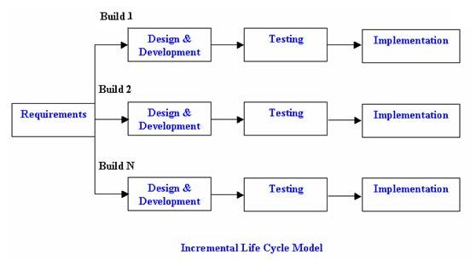

**Figure4**: Incremental Life Cycle Model

The incremental build model is a method of software development where the model is designed, implemented and tested incrementally (a little more is added each time) until the product is finished. It involves both development and maintenance. The product is defined as finished when it satisfies all of its requirements. This model combines the elements of the waterfall model with the iterative philosophy of prototyping.

The product is decomposed into a number of components, each of which are designed and built separately (termed as builds). Each component is delivered to the client when it is complete. This allows partial utilization of product and avoids a long development time.

It also creates a large initial capital outlay with the subsequent long wait avoided. This model of development also helps ease the traumatic effect of introducing completely new system all at once.

There are some problems with this model. One is that each new build must be integrated with previous builds and any existing systems. The task of decomposing product into builds not trivial either. If there are too few builds and each build degenerates this turns into Build-And-Fix model. However if there are too many builds then there is little added utility from each build.

COST AND BENEFIT ANALYSIS

# 5. COST AND BENEFIT ANALYSIS

# 5.1 COST AND BENEFIT ANALYSIS

Understanding "What’s in the Cost"

* Direct Costs - Attributable to the Project:

Materials, Project Related Travel

* Indirect (Overhead) Costs - Necessary Business Expenses:

# 5.2 COCOMO MODEL

The basic COCOMO model gives an approximate estimate of the project parameters. The basic COCOMO estimation model is given by the following expressions:

**Effort = a1 х (KLOC) a 2 PM**

**Tdev = b1 x (Effort) b2 Months**

Where

* KLOC is the estimated size of the software product expressed in Kilo Lines of Code,
* a1, a2, b1, b2 are constants for each category of software products,
* Tdev is the estimated time to develop the software, expressed in months,
* Effort is the total effort required to develop the software product, expressed in person months (PMs).

## Estimation of development effort

For the three classes of software products, the formulas for estimating the effort based on the code size are shown below:

**Organic: Effort = 2.4(KLOC) 1.05 PM**

**Semi-detached: Effort = 3.0(KLOC) 1.12 PM**

**Embedded: Effort = 3.6(KLOC) 1.20 PM**

Estimation of development time

For the three classes of software products, the formulas for estimating the development time based on the effort are given below:

**Organic: Tdev = 2.5(Effort) 0.38 Months**

**Semi-detached: Tdev = 2.5(Effort) 0.35 Months**

**Embedded: Tdev = 2.5(Effort) 0.32 Months**

## Cost Estimation of our project using basic COCOMO Model

As the size of our project has been estimated to be 5,000 lines of source code. Assume that the average salary of software engineers be Rs. 5,000/- per month. Determine the effort required to develop the software product and the nominal development time.

From the basic COCOMO estimation formula for organic software:

**Effort = 2.4 х (3)1.05 = 7 PM**

**Nominal development time = 2.5 х (7)0.38 = 5 months**

H/W AND S/W REQUIREMENTS

# 6. HARDWARE & SOFTWARE REQUIREMENTS

# 6.1 HARDWARE REQUIREMENTS:

* RAM : 4GB or above
* Memory : 100GB or above.
* Processor : Intel Core series or AMD quad core for development
* Internet Availability : Wi-Fi, Ethernet or 3G, 4G

# 6.2 SOFTWARE REQUIREMENTS:

* Operating System : Windows 7 or Above.
* Language Used : JSP,HTML5
* Database : MySQL Server
* Server : Apache

FEASIBILITY STUDY

# 7. FEASIBILITY STUDY

# Feasibility studies aim to objectively and rationally uncover the strengths and weaknesses of an existing business or proposed venture, opportunities and threats as presented by the environment, the resources required to carry through, and ultimately the prospects for .success. When writing a feasibility report the following should be taken to consideration:

* A brief description of the business to assess more possible factor/s which could affect the study
* The part of the business being examined
* The human and economic factor
* The possible solutions to the problems

# 7.1 TECHNICAL FEASIBILITY

The technical feasibility assessment is focused on gaining an understanding of the present technical resources of the organization and their applicability to the expected needs of the proposed system. It is an evaluation of the hardware and software and how it meets the need of the proposed system.

As per the hardware requirements the system works with existing hardware. As per the software requirements the project works on Microsoft Visual Studio 2010 and SQL Server 2008 Management Studio. Hence this project is technically feasible.

# 7.2 ECONOMICFEASIBILITY

Economic analysis is the most frequently used method for evaluating the effectiveness of a new system. More commonly known as cost/benefit analysis, the procedure is to determine the benefits and savings that are expected from a candidate system and compare them with costs. If

Benefits outweigh costs, then the decision is made to design and implement the system. An entrepreneur must accurately weigh the cost versus benefits before taking an action.

## 7.2.1 Cost-based study:

It is important to identify cost and benefit factors, which can be categorized as follows:

1. Development costs 2. Operating costs.

This is an analysis of the costs to be incurred in the system and the benefits derivable out of the system.

As the number of members in the project is less and the project has a limited scope, the development cost involved in the project is minim um. Also there is no training involved in this so operating cost in almost to Rs 5,990. Hence this project is has benefits compared to the investments.

## 7.2.2 Time-based study:

This is an analysis of the time required to achieve a return on investments. The future value of a project is also a factor.

The project is estimated to get finished in 4 months and the seeing the progress of the same we can come to a conclusion that the project will finish within time.

From the above Cost-based study and Time-Based study we can infer that this project has benefits and hence it is economically feasible.

# 7.3 OPERATIONAL FEASIBILITY

An estimate should be made of how strong a reaction the user staff is likely to have towards the development of a computerized system.

The interfaces of the software developed are really user friendly and hence there is no possibility for any resistance from the users. Also the colours used for the interfaces are sober and will not affect any user. Apart from the interfaces used the ease with which the software works is remarkable and any user can easily learn to work with it. Hence this project is operationally feasible.

ANALYSIS OF THE SYSTEM

# 8. ANALYSIS OF THE SYSTEM

# 8.1 IDENTIFICATION OF NEED

In developing countries, the number of mobile phone users exceeds the number of those having bank accounts and give an amazing opportunity for banks to engage with customers with payment services like never before.

In this busy world everything needs to be completed at a very fast rate

The payment needs to be completed fast without compromising on the security.

Flip pay provides an alternative next generation payment system through which payments can be made at retail stores via the mobile phones by scanning a QR Code placed at the stores.

# 8.2 PRELIMINARY INVESTIGATION

One of the major problem that has been not addressed is that the predefined accurate rate list of the crops. Unknowingly the crops accurate price famer selling his crops at low price. If a crop is good or bad, the farmer may end up getting the low profit. Farmer to be required to ask the merchant for confirmation. Various parties have expressed interest in a system which would notify the merchant that a visually impaired farmer to get correct price. This would benefit the farmer could then take getting profit in a good manner.

# 8.3 FUNCTIONALAND NON-FUNCTIONAL REQUIREMENTS

# 8.3.1 Functional Requirements

* **Registration of Farmer, Merchant:** The system shall store the farmers and merchants details, information about crops shall be included in the System.
* **Login:** Admin can login and see the details of farmers and merchants.
* **Search respective merchant details:** Farmers has to fill the crops details. To view the respective merchant for a selling a crops. Famer has to select crops in the drop-down menu, which crops he want to sell. Farmers can also get the merchant details.
* **Details of System working**: The application will provide farmer and merchants contact details with crops details and allows them to sell and purchasing the crops. It display accurate price of crops for farmers and merchants.

# Non-Functional Requirements

* **Speed:** Our application is fast working. As it takes less time to reload pages.
* **Reliability:** This software meets all the requirement that was specified at the time of requirement gathering. Hence this Application is consistently good in quality and performance.
* **Ease of use:** It is not so complicated that a user with some knowledge of using internet can use the Application.
* **Portable:** The Application is not portable because it is developed with JSP, HTML5.
* **Security:** Details are stored in encrypted format.

# 8.4 Context Level DFD:

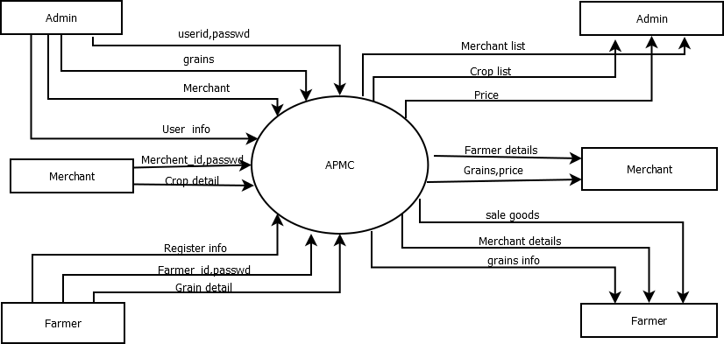

**Figure 8.4:** Context level DFD

## 

## 8.4.1 Top Level DFD:

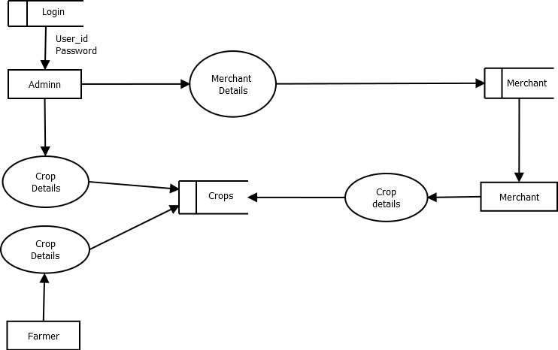

**Figure 8.4.1**: Top level DFD

# 8.5.1 ADMIN CASE DIAGRAM:

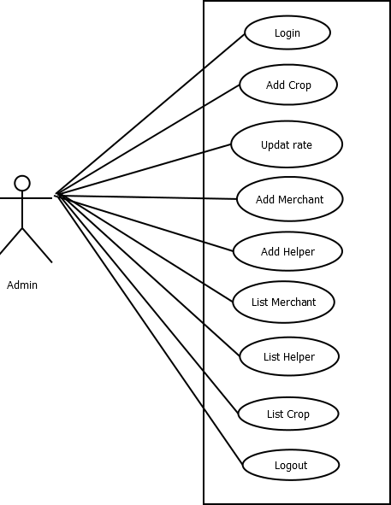

**Figure 8.5.1 Admin Use case diagram**

# 8.5.2 FARMER CASE DIAGRAM:

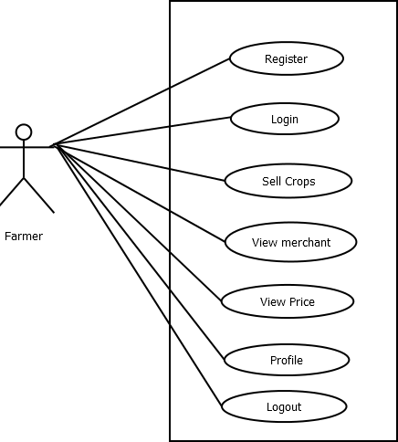

**Figure 8.5.2 Farmer Use case diagram**

# 8.5.3 MERCHANT USE CASE DIAGRAM:

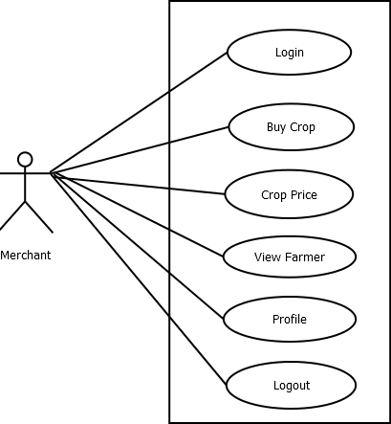

**Figure 8.5.3 Merchant Use case diagram**

# 8.6 ACTIVITY DIAGRAMS:

## 8.6.1 ADMIN ACIVITY DIAGRAM:

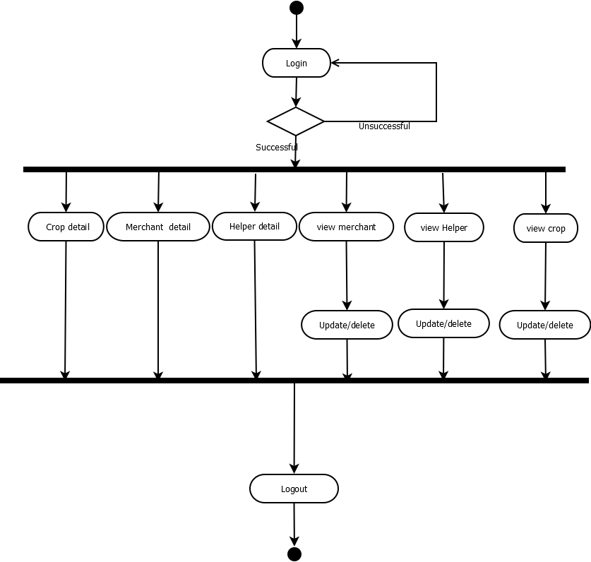

8.6.2 DEVELOPER ACIVITY DIAGRAM:

## FARMER ACTIVITY DIAGRAM

## C:\Users\Pandurang\Desktop\diagram\Farmera.png

## 

## 8.6.3 MERCHANT ACIVITY DIAGRAM:

## C:\Users\Pandurang\Desktop\diagram\Mercha.png

DESIGN

# 9. DESIGN

## 9.1 ENTITY RELATIONSHIP DIAGRAM:

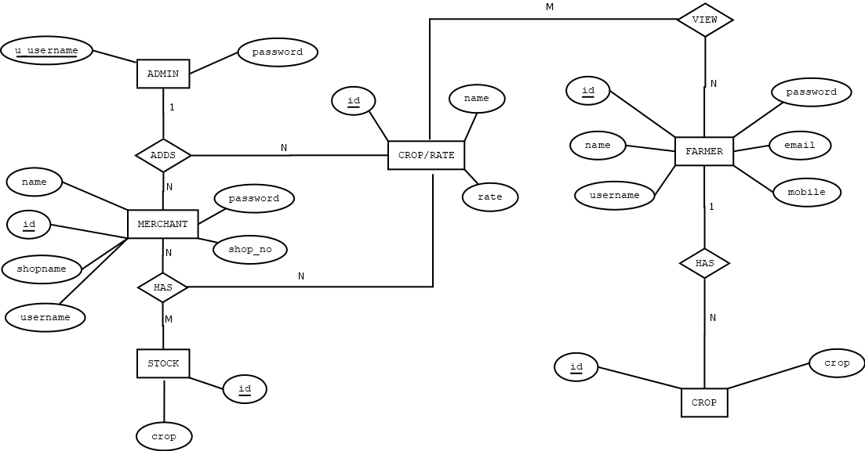

# 9.2 DATA STRUCTURE

### 

### 9.2.1 Login Table:

|  |  |  |
| --- | --- | --- |
| Column Name | Data Type | Description |
| username | varchar(50) | Primary key |
| Password | varchar(50) | - |

### 9.2.2 Farmergrains Table:

|  |  |  |
| --- | --- | --- |
| Column Name | Data Type | Description |
| username | varchar(50) | Primary key |
| Item | varchar(50) | - |

## 9.2.3 Farmer Table:

|  |  |  |  |
| --- | --- | --- | --- |
| Column Name | Data Type | Description | |
| Id | int(11) | Primary Key | |
| Username | varchar(50) | - | |
| Password | Varchar(50) | - |  |
| fname | Varchar(50) | - |  |
| Lname | Varchar(50) | - |  |
| Address | Varchar(200) |  |  |
| email | Varchar(50) | - |  |
| Mobile | Varchar(20) | - |  |

## 

## 9.2.4 Farmergrains Table:

|  |  |  |
| --- | --- | --- |
| Column Name | Data Type | Description |
| username | Integer(11) | Primary Key |
| Item | Varchar(50) | - |

# 

# 9.2.5 Items Table:

|  |  |  |
| --- | --- | --- |
| Column Name | Data Type | Description |
| Slno | Integer(11) | Primary Key |
| Item | Varchar(50) | - |
| Rate | Flaot | - |

# 

# 9.2.6 Send Table

|  |  |  |
| --- | --- | --- |
| Column Name | Data Type | Description |
| Mobile | Varchar(10) | Primary Key |
| Item | Varchar(50) | - |
| Price | Varchar(20) | - |

# 

# 9.2.7 Merchant Table:

|  |  |  |  |
| --- | --- | --- | --- |
| Column Name | Data Type | Description | |
| Id | int(11) | Primary Key | |
| Username | varchar(50) | - | |
| Password | Varchar(50) | - |  |
| Fname | Varchar(50) | - |  |
| Lname | Varchar(50) | - |  |
| shopno | Varchar(20) |  |  |
| Shopname | Varchar(50) | - |  |
| Contact | Varchar(20) | - |  |

SOURCE CODE

# 10.SOURCE CODE:

## 10.1. Index.jsp

<!DOCTYPE html>

<html lang="en">

<head>

<title>index</title>

<meta charset="utf-8">

<meta name="viewport" content="width=device-width, initial-scale=1.0">

<meta name="description" content="Your description">

<meta name="keywords" content="Your keywords">

<meta name="author" content="Your name">

<link rel="icon" href="images/favicon.ico" type="image/x-icon">

<link rel="shortcut icon" href="images/favicon.ico" type="image/x-icon" />

<link rel="stylesheet" href="css/bootstrap.css" type="text/css" media="screen">

<link rel="stylesheet" href="css/bootstrap-responsive.css" type="text/css" media="screen">

<link rel="stylesheet" href="css/style.css" type="text/css" media="screen">

<link rel="stylesheet" href="css/camera.css" type="text/css" media="screen">

<script type="text/javascript" src="js/jquery.js"></script>

<script type="text/javascript" src="js/jquery.easing.1.3.js"></script>

<script type="text/javascript" src="js/superfish.js"></script>

<script type="text/javascript" src="js/jquery.ui.totop.js"></script>

<script type="text/javascript" src="js/camera.js"></script>

<script type="text/javascript" src="js/jquery.mobile.customized.min.js"></script>

<script>

$(document).ready(function() {

/////// icons

$(".social li").find("a").css({opacity:0.6});

$(".social li a").hover(function() {

$(this).stop().animate({opacity:1 }, 400, 'easeOutExpo');

},function(){

$(this).stop().animate({opacity:0.6 }, 400, 'easeOutExpo' );

});

// camera

$('#camera_wrap').camera({

//thumbnails: true

autoAdvance : true,

mobileAutoAdvance : true,

height: '37%',

hover: false,

loader: 'none',

navigation: false,

navigationHover: false,

mobileNavHover: false,

playPause: false,

pauseOnClick: false,

pagination : true,

time: 7000,

transPeriod: 1000,

minHeight: '300px'

});

}); //

$(window).load(function() {

//

}); //

</script>

<!--[if lt IE 8]>

<div style='text-align:center'><a href="http://www.microsoft.com/windows/internet-explorer/default.aspx?ocid=ie6_countdown_bannercode"><img src="http://www.theie6countdown.com/images/upgrade.jpg"border="0"alt=""/></a></div>

<![endif]-->

<!--[if lt IE 9]>

<script src="http://html5shim.googlecode.com/svn/trunk/html5.js"></script>

<link rel="stylesheet" href="css/ie.css" type="text/css" media="screen">

<![endif]-->

</head>

<body>

<%

if(request.getParameter("msg")!=null){

String msg=request.getParameter("msg");

%><script> alert('<%=msg%>')</script><%

}

%>

<div id="main">

<header>

<div class="logo_wrapper"><a href="index.html" class="logo"><img src="images/logo1.png" alt=""></a></div>

<div class="top1">

<div class="container">

<div class="row">

</div>

</div>

</div>

<div class="top2">

<div class="container">

<div class="row">

<div class="span12">

<div class="top2_inner">

<div class="navbar navbar_">

<div class="navbar-inner navbar-inner_">

<a class="btn btn-navbar btn-navbar_" data-toggle="collapse" data-target=".nav-collapse_">

<span class="icon-bar"></span>

<span class="icon-bar"></span>

<span class="icon-bar"></span>

</a>

<div class="nav-collapse nav-collapse_ collapse">

<ul class="nav sf-menu clearfix">

<li class="active"><a href="index.jsp">Login</a></li>

</ul>

</div>

</div>

</div>

</div>

</div>

</div>

</div>

</div>

</header>

<div id="slider" class="clearfix">

<div id="camera_wrap">

<div data-src="images/slide2.jpg">

<div class="camera_caption fadeIn">

<div class="txt1">Farmer don't just work till the sun goes down </div>

<div class="txt2">They work till the job gets done.</div>

</div>

</div>

<div data-src="images/slide3.jpg">

<div class="camera_caption fadeIn">

<div class="txt1">Farmer don't just work till the sun goes down </div>

<div class="txt2">They work till the job gets done.</div>

</div>

</div>

<div data-src="images/slide4.jpg">

<div class="camera_caption fadeIn">

<div class="txt1">Farmer don't just work till the sun goes down </div>

<div class="txt2">They work till the job gets done.</div>

</div>

</div>

</div>

</div>

<div id="content">

<div id="content2">

<div id="inner">

<div class="banners">

<div class="container">

<div class="row">

<div class="span4 banner banner1">

<div class="txt1"><font color="red">Farmer Login</font></div>

<form id="ajax-contact-form" action="login.jsp" class="form-horizontal">

<input type="hidden" name="f" value="Farmer"/>

<div class="row">

<div class="span5">

<div class="control-group">

<div class="controls">

<input class="span5" type="text" name="user" style="width: 250px;" Placeholder="Username" />

</div>

</div>

<div class="control-group">

<div class="controls">

<input class="span5" type="Password" name="pass" style="width: 250px;" Placeholder="Password" />

</div>

</div>

<input class="submit" type="submit" name="pass" style="width: 250px;" value="Login" /><br/>

<a href="createfarmer.jsp" class="button1"> <font color="red"> New Farmer Registration</a>

</div>

</div>

</form>

</div>

<div class="span4 banner banner2">

<div class="txt1"><font color="red">Merchant Login</font></div>

<form id="ajax-contact-form" action="login.jsp" class="form-horizontal">

<input type="hidden" name="f" value="Merchant"/>

<div class="row">

<div class="span5">

<div class="control-group">

<div class="controls">

<input class="span5" type="text" name="user" style="width: 250px;" Placeholder="Username" />

</div>

</div>

<div class="control-group">

<div class="controls">

<input class="span5" type="Password" name="pass" style="width: 250px;" Placeholder="Password" />

</div>

</div>

<input class="submit" type="submit" name="pass" style="width: 250px;" value="Login" />

</div>

</div>

</form>

</div>

<div class="span4 banner banner3">

<div class="txt1"><font color="red">Admin Login</font></div>

<form id="ajax-contact-form" action="login.jsp" class="form-horizontal">

<input type="hidden" name="f" value="Admin"/>

<div class="row">

<div class="span5">

<div class="control-group">

<div class="controls">

<input class="span5" type="text" name="user" style="width: 250px;" Placeholder="Username" />

</div>

</div>

<div class="control-group">

<div class="controls">

<input class="span5" type="password" name="pass" style="width: 250px;" Placeholder="Password" />

</div>

</div>

<input class="submit" type="submit" name="pass" style="width: 250px;" value="Login" />

</div>

</div>

</form>

</div>

</div>

</div>

</div>

</div>

</div>

</div>

<footer>

<div class="container">

<div class="row">

<div class="span12">

<div class="bot clearfix">

<div class="bot1">

<div class="menu_bot">

<ul id="menu_bot" class="clearfix">

<li><a href="index.jsp">Login</a></li>

</ul>

</div>

</div>

</div>

</div>

<div class="copyright">Copyright © 2019. All rights reserved.</div>

</div>

</div>

</div>

</footer>

</div>

<script type="text/javascript" src="js/bootstrap.js"></script>

</body>

</html>

## 10.2. createfarmer.jsp

<%@page import="java.sql.*"%>

<!DOCTYPE html>

<html lang="en">

<head>

<title>Farmer</title>

<meta charset="utf-8">

<meta name="viewport" content="width=device-width, initial-scale=1.0">

<meta name="description" content="Your description">

<meta name="keywords" content="Your keywords">

<meta name="author" content="Your name">

<link rel="icon" href="images/favicon.ico" type="image/x-icon">

<link rel="shortcut icon" href="images/favicon.ico" type="image/x-icon" />

<link rel="stylesheet" href="css/bootstrap.css" type="text/css" media="screen">

<link rel="stylesheet" href="css/bootstrap-responsive.css" type="text/css" media="screen">

<link rel="stylesheet" href="css/style.css" type="text/css" media="screen">

<link rel="stylesheet" href="css/camera.css" type="text/css" media="screen">

<script type="text/javascript" src="js/jquery.js"></script>

<script type="text/javascript" src="js/jquery.easing.1.3.js"></script>

<script type="text/javascript" src="js/superfish.js"></script>

<script type="text/javascript" src="js/jquery.ui.totop.js"></script>

<script type="text/javascript" src="js/camera.js"></script>

<script type="text/javascript" src="js/jquery.mobile.customized.min.js"></script>

<script lang="javascript">

function validate(){

var p1=document.f.pass1.value;

var p2=document.f.pass2.value;

if(p1.length<8)

{

alert("Enter atleast 8 charecter");

return false;

}

if(p1!=p2){

alert("Password does not match");

return false;

}

var reg1=/^[a-zA-Z\-][a-zA-Z]+$/;

var user=document.f.fname.value;

var res1=user.search(reg1);

var login=document.f.fname.value;

var res=login.search(reg1);

if(res==-1)

{

alert('Invalid First Name. It should start with Alphabet');

return false;

}

var reg2=/^[a-zA-Z\-][a-zA-Z0-9]+$/;

var user2=document.f.lname.value;

var res2=user2.search(reg2);

var login2=document.f.lname.value;

var res2=login2.search(reg2);

if(res2==-1)

{

alert('Please check last name');

return false;

}

if(isNaN(document.f.mobno.value))

{

alert("Enter valid mobile no")

return false;

}

var em=document.f.email.value;

if(em!=""){

var reg = /^([A-Za-z0-9_\-\.])+\@([A-Za-z0-9_\-\.])+\.([A-Za-z]{2,4})$/;

var address = document.f.email.value;

if(reg.test(address) == false) {

alert('Invalid Email Address');

return false;

}

}

if((document.f.mobno.value.length>10)||(document.f.mobno.value.length<10))

{

alert("Mobile Number should be 10 digit");

return false;

}

return true;

}

</script>

<script>

$(document).ready(function() {

/////// icons

$(".social li").find("a").css({opacity:0.6});

$(".social li a").hover(function() {

$(this).stop().animate({opacity:1 }, 400, 'easeOutExpo');

},function(){

$(this).stop().animate({opacity:0.6 }, 400, 'easeOutExpo' );

});

// camera

$('#camera_wrap').camera({

//thumbnails: true

autoAdvance : true,

mobileAutoAdvance : true,

height: '37%',

hover: false,

loader: 'none',

navigation: false,

navigationHover: false,

mobileNavHover: false,

playPause: false,

pauseOnClick: false,

pagination : true,

time: 7000,

transPeriod: 1000,

minHeight: '300px'

});

}); //

$(window).load(function() {

//

}); //

</script>

<!--[if lt IE 8]>

<div style='text-align:center'><a href="http://www.microsoft.com/windows/internet-explorer/default.aspx?ocid=ie6_countdown_bannercode"><img src="http://www.theie6countdown.com/images/upgrade.jpg"border="0"alt=""/></a></div>

<![endif]-->

<!--[if lt IE 9]>

<script src="http://html5shim.googlecode.com/svn/trunk/html5.js"></script>

<link rel="stylesheet" href="css/ie.css" type="text/css" media="screen">

<![endif]-->

</head>

<body>

<div id="main">

<header>

<div class="logo_wrapper"><a href="index.html" class="logo"><img src="images/logo1.png" alt=""></a></div>

<div class="top1">

<div class="container">

<div class="row">

</div>

</div>

</div>

<div class="top2">

<div class="container">

<div class="row">

<div class="span12">

<div class="top2_inner">

<div class="navbar navbar_">

<div class="navbar-inner navbar-inner_">

<a class="btn btn-navbar btn-navbar_" data-toggle="collapse" data-target=".nav-collapse_">

<span class="icon-bar"></span>

<span class="icon-bar"></span>

<span class="icon-bar"></span>

</a>

<div class="nav-collapse nav-collapse_ collapse">

<ul class="nav sf-menu clearfix">

<li><a href="logout.jsp">Back</a></li>

</ul>

</div>

</div>

</div>

</div>

</div>

</div>

</div>

</div>

</header>

<div id="slider" class="clearfix">

<div id="camera_wrap">

<div data-src="images/f1.jpg">

<div class="camera_caption fadeIn">

<div class="txt2">Farmer is the backbone of our country </div>

</div>

</div>

<div data-src="images/f2.jpg">

<div class="camera_caption fadeIn">

<div class="txt2">Farmer is the backbone of our country </div>

</div>

</div>

<div data-src="images/slide2.jpg">

<div class="camera_caption fadeIn">

<div class="txt2">Farmer is the backbone of our country </div>

</div>

</div>

</div>

</div>

<div id="content">

<div id="content2">

<div id="content">

<div id="content2">

<div id="inner">

<div class="banners">

<div class="container">

</div>

</div>

<div id="inner2">

<div class="container">

<div class="row">

<div class="span8">

<div id="fields">

<h2>Farmer Registration</h2>

<form name="f" id="ajax-contact-form" method="post" class="form-horizontal"

action="" onsubmit="javascript:return validate()">

<div class="row">

<div class="span5">

<div class="control-group">

<div class="controls">

<input class="span5" type="text" name="user" placeholder="Username"required autofocus/>

</div>

</div>

<div class="control-group">

<div class="controls">

<input class="span5" type="password" name="pass1" placeholder="Password" required/>

</div>

</div>

<div class="control-group">

<div class="controls">

<input class="span5" type="password" name="pass2" placeholder="Re-enter Password" required/>

</div>

</div>

<div class="control-group">

<div class="controls">

<input class="span5" type="text" name="fname" placeholder="First Name" required />

</div>

</div>

<div class="control-group">

<div class="controls">

<input class="span5" type="text" name="lname" placeholder="Last Name" required />

</div>

</div>

<div class="control-group">

<div class="controls">

<textarea class="span5" name="addr" placeholder="Address" ></textarea>

</div>

</div>

<div class="control-group">

<div class="controls">

<input class="span5" type="email" name="email" placeholder="Email" />

</div>

</div>

<div class="control-group">

<div class="controls">

<input class="span5" type="text" name="mobno" placeholder="Mobile Number"

pattern="[6789][0-9]{9}" required />

</div>

</div>

<div class="control-group">

<div class="controls">

<button type="submit" class="submit"><em></em>submit</button>

</div>

</div>

</div>

</form>

<%

if(request.getParameter("user")!=null){

try{

Class.forName("com.mysql.jdbc.Driver");

Connection con=DriverManager.getConnection("jdbc:mysql://localhost:3306/apmc","root","");

Statement st=con.createStatement();

ResultSet rs=null;

rs=st.executeQuery("select * from tblfarmer where username='"+ request.getParameter("user")+"'");

if(rs.next()){

out.print("<script> alert('Username Already Present') </script>");

}else{

int i=st.executeUpdate("insert into tblfarmer(username,password,fname,lname,address,email,mobile) values('"+request.getParameter("user")+"','"+request.getParameter("pass1")+"','"+request.getParameter("fname")+"','"+request.getParameter("lname")+"','"+request.getParameter("addr")+"','"+request.getParameter("email")+"','"+request.getParameter("mobno")+"')");

if(i>0){

out.print("<script> alert('Registration Successful. Please login to continue...');

window.location.href='index.jsp'; </script>");

}else{

out.print("<script> alert('Unsuccessful Registration') </script>");

}

}

}catch(Exception ex){

out.print(ex);

}

}

%>

</div>

</div>

</div>

</div>

</div>

</div>

</div>

</div>

<footer>

<div class="container">

<div class="row">

<div class="span12">

</div>

<div class="copyright">Copyright © 2019. All rights reserved.</div>

</div>

</div>

</div>

</footer>

</div>

<script type="text/javascript" src="js/bootstrap.js"></script>

</body>

</html>

SCREEN LAYOUTS

# 

# 11.SCREEN LAYOUTS:

Loginpage:

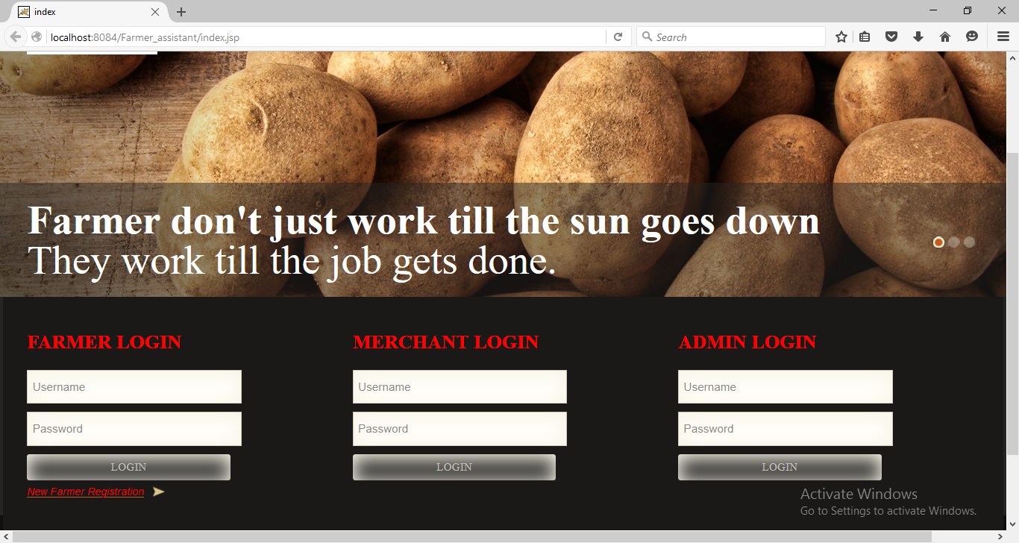

Figure 11.1-Loginpage

Farmer Registration :

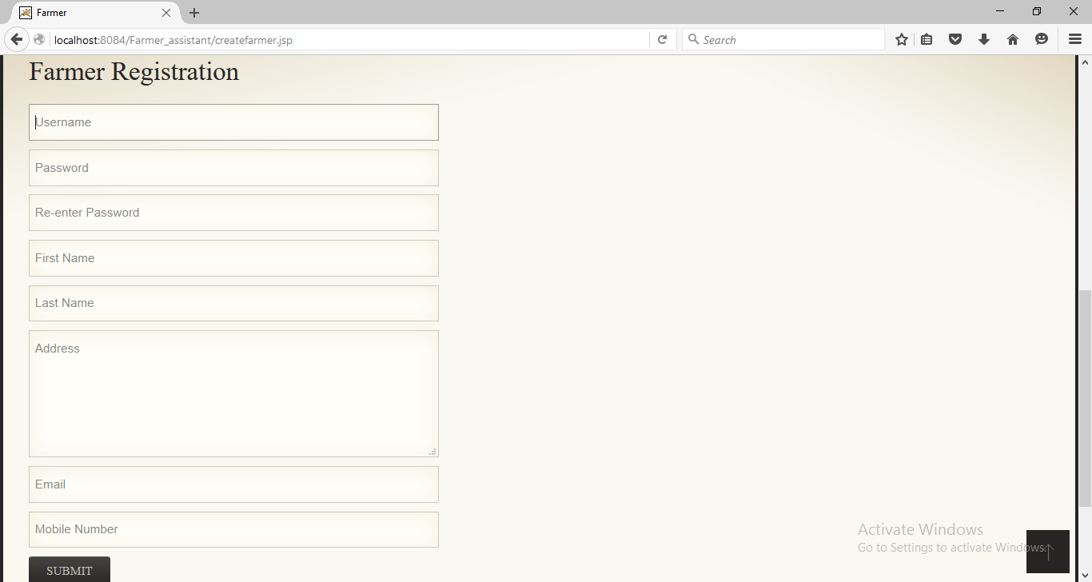

Figure 11.2-Farmer Registration.

Farmer Homepage:

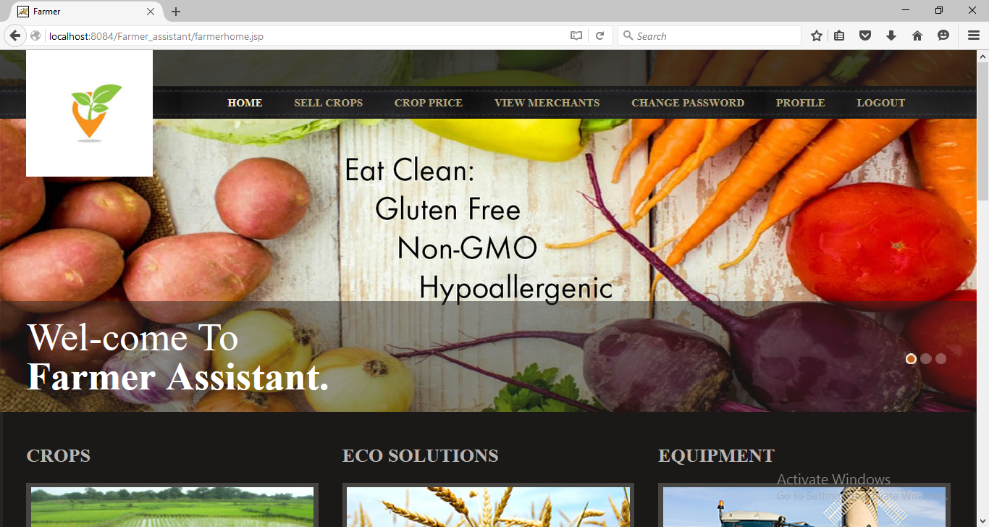

Figure 11.3-Farmer Homepage.

Viewmerchat :

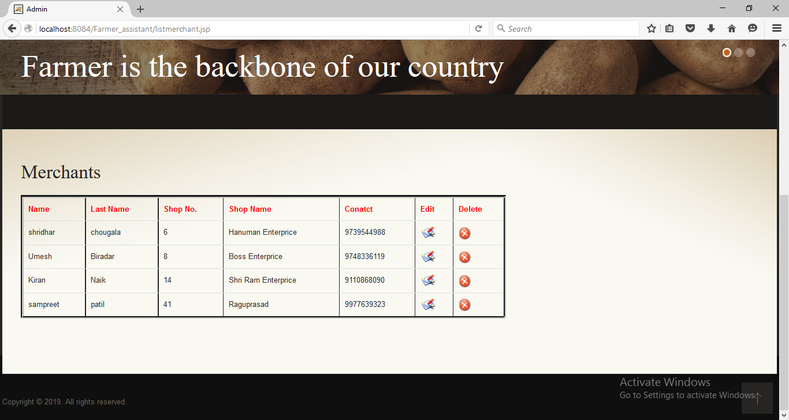

Figure 11.4-Farmer viewmerhant.

Admin Home :

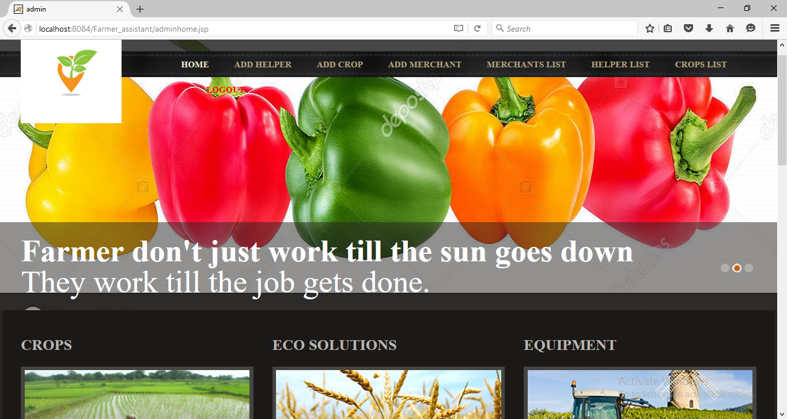

Figure 11.5-Admin Home.

Admin croplist:

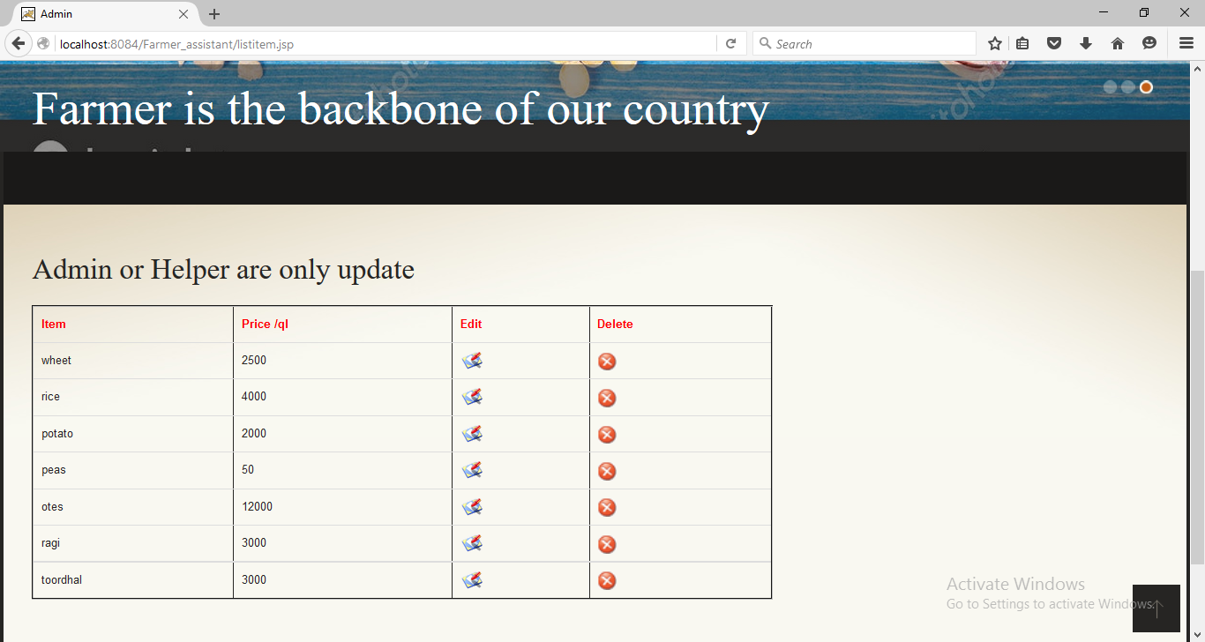Figure 11.6-Admin Croplist.

SYSTEM TESTING

# 12. SYSTEM TESTING

# SYSTEM TESTING

System testing is a critical aspect of Software Quality Assurance and represents the ultimate review of specification, design and coding. Testing is a process of executing a program with the intent of finding an error. A good test is one that has a probability of finding an as yet undiscovered error. The purpose of testing is to identify and correct bugs in the developed system. Nothing is complete without testing. Testing is the vital to the success of the system.

## 12 .1 BLACK -BOX TESTING

In black-box testing, the tester only knows the inputs that can be given to the system and what output the system should give. In other words, the basis for deciding test cases is the requirements or specifications of the system or module. This form of testing is also called functional or behavioral testing.

The most obvious functional testing procedure is exhaustive testing, which is impractical. One criterion for generating test cases is to generate them randomly. This strategy has little chance of resulting in a set of test cases that is close to optimal (i.e., that detects the maximum errors with minimum test cases). Hence, we need some other criterion or rule for selecting test cases. There are no formal rules for designing test cases for functional testing.

However, there are a number of techniques or heuristics that can be used to select test cases that have been found to be very successful in detecting errors.

## 12. 2 WHITE - BOX TESTING

White-box testing, on the other hand, is concerned with testing the implementation of the program. The intent of this testing is not to exercise all the different input or output conditions (although that may be a by-product) but to exercise the different programming structures and data structures used in the program. White-box testing is also called structural testing, and we will use the two terms interchangeably. To test the structure of a program, structural testing aims to achieve test cases that will force the desired coverage of different structures. Various criteriahave been proposed for this. Unlike the criteria for functional testing, which are frequently imprecise, the criteria for structural testing are generally quite precise as they are based on program structures.

TEST REPORT

# 13. TEST REPORT

     The primary goal of software implementation is the production of source code that is easy to read and understand.  Clarification of source code helps in easier debugging, testing and modification.  Source code clarification is enhanced by structural coding techniques, by good coding style, by appropriate supporting documents, by good internal comments and by the features provided in the modern programming language.

**TEST CASES REPORT FOR USER REGISTRATION FORM**

|  |  |  |  |  |  |  |  |  |
| --- | --- | --- | --- | --- | --- | --- | --- | --- |
| **Test Case id** | **Test Cases** | **Test case Description** | **Steps To be Executed** | | **Expected Results** | | **Actual results** | **Status**  **(Pass/**  **Fail)** |
| TC01 | Username | 1.Test Username field with correct Validations. | 1.Enter valid Username  2.Click on Submit button. | | After entering valid Username it must be accepted. | | Accepted  Username | Pass |
| 2.Test Username field with incorrect Validations. | 1.Enter invalid Usename like numbers.  2.Click on Submit button. | | After entering invalid Username it should display a message(Please match the requested format:Username must be in Lower case or Upper case letter). | |  | Pass |
| 3.Test Usernam e field without entering the field. | 1.Direct Click on Submit button. | | it should display a proper Error message(Please fill out this field). | |  | Pass |
| TC02 | Phone No | 1.Test Phone field with correct Validations. | 1.Enter valid Phone number  2.Click on Submit button. | | After entering valid Phone it must be accepted. | | Accepted  Phone number | Pass |
| 2.Test Phone field with incorrect Validations. | 1.Enter invalid Phone No.  2.Click on Submit button. | | After entering invalid Phone No it should display a message(Please enter a valid Phone No). | |  | Pass |
| 3.Test Phone field without entering the field. | 1.Direct Click on Submit button | | it should display a proper Error message(Please fill out this field). | |  | Pass |
| TC03 | Mobile No | 1.Test Mobile No field with correct Validations. | 1.Enter valid Mobile No  2.Click on Submit button. | | After entering valid Mobile No it must be accepted. | | Accepted  Mobile No | Pass |
| 2.Test Mobile No field with incorrect Validations. | 1.Enter invalid Mobile No like entering only 8 or 9 digit numbers.  2.Click on Submit button. | | After entering invalid Mobile No it should display a message(Please match the requested format:Enter 10 digit mobile no starting with 9 or 8 or 7). | |  | Pass |
| 3.Test Mobile No without entering the field. | 1.Direct Click on Submit button | | it should display a proper Error message(Please fill out this field). | |  | Pass |
| TC04 | Address | 1.Test Address field with correct Validations. | 1.Enter valid Address  2.Click on Submit button. | | After entering valid Address it must be accepted. | | Accepted  Address | Pass |
| 2.Test Username field with incorrect Validations. | 1.Enter invalid Address.  2.Click on Submit button. | | After entering invalid Address it should display a message(Please enter a valid Address). | |  | Pass |
| 3.Test Address without entering the field. | 1.Direct Click on Submit button | | it should display a proper Error message(Please fill out this field). | |  | Pass |
| TC05 | Password | 1.Test Password field with correct Validations. | 1.Enter valid Password  2.Click on Submit button. | | After entering valid Password it must be accepted. | | Accepted Password | Pass |
| 2.Test Password field with incorrect Validations. | 1.Enter invalid Password like entering less than 8 and more than 20 character long.  2.Click on Submit button. | | After entering invalid Password it should display a message(Please match the requested format:Password must be of minimum 8 and maximum 20 character long). | |  | Pass |
| 3.Test Password without entering the field. | 1.Enter username field  2. Click on Submit button. | | it should display a proper Error message(Please fill out this field). | |  | Pass |
| TC02 | Email | 1.Test Email field with correct Validations. | | 1.Enter valid Email  2.Click on Submit button. | | After entering valid Email it must be accepted. | Accepted  Email id | Pass |
| 2.Test Email field with incorrect Validations. | | 1.Enter invalid Email like without entering ‘@’ symbol.  2.Click on Submit button. | | After entering invalid Email it should display a message(Please include an ‘@’ in the Email id). |  | Pass |
| 3.Test Email field without entering the field. | | 1.Enter Full Name field  2. Click on Submit button. | | it should display a proper Error message(Please fill out this field). |  | Pass |
| 2.Test Mobile No field with incorrect Validations. | | 1.Enter invalid Mobile No like entering only 8 or 9 digit numbers.  2.Click on Submit button. | | After entering invalid Mobile No it should display a message(Please match the requested format:Enter 10 digit mobile no starting with 9 or 8 or 7). |  | Pass |
| 3.Test Mobile No without entering the field. | | 1.Enter Email field  2. Click on Submit button. | | it should display a proper Error message(Please fill out this field). |  | Pass |
| TC07 | Phone No | 1.Test Phone field with correct Validations. | | 1.Enter valid Phone number  2.Click on Submit button. | | After entering valid Phone it must be accepted. | Accepted  Phone number | Pass |
| 2.Test Phone field with incorrect Validations. | | 1.Enter invalid Phone No.  2.Click on Submit button. | | After entering invalid Phone No it should display a message(Please enter a valid Phone No). |  | Pass |
| 3.Test Phone field without entering the field. | | 1.Direct Click on Submit button | | it should display a proper Error message(Please fill out this field). |  | Pass |
| TC08 | Test if user is able to Register  successfully. | 1.Test all fields. | 1. Enter all valid Data Fields. 2. Click on Submit button | | User must successfully Register. | | User has Registered | Pass |

BIBLOGRAPHY

# 14. BIBLOGRAPHY

# 14.1 WEBSITES REFERRE

https://www.w3schools.com/

http://colorlib.com/  
http://google.com/